National Textile University, Faisalabad

Department of Computer Science
Name | Dawood Saif
Class | SE-6th (A)
Reg. No. | 23-NTU-CS-1145
Course | Mobile Application Development
Submitted To | Sir Rehan Sarwar
Submission Date | 02/03/2026
Lab Plan | 2

Lab Module: Flutter Layouts & Alignment

Lab Tasks
Task 1: The "Safe" Container
Objective: Understand the Box Model and SafeArea implementation.
  - Instruction: Create a new Flutter project and generate a StatelessWidget using the stless shortcut.
  - Requirements:
    - Set the Scaffold background color to Colors.blueGrey. o Wrap the body of your Scaffold in a SafeArea widget.
    - Inside the SafeArea, create a Container with a width and height of 250. o Apply a margin of 25 pixels on all sides using EdgeInsets.all(25.0).
    - Apply a padding of 15 pixels to the top and bottom using EdgeInsets.symmetric.
  - Discussion Point: Why is SafeArea necessary for modern smartphones with notches?.

Code:
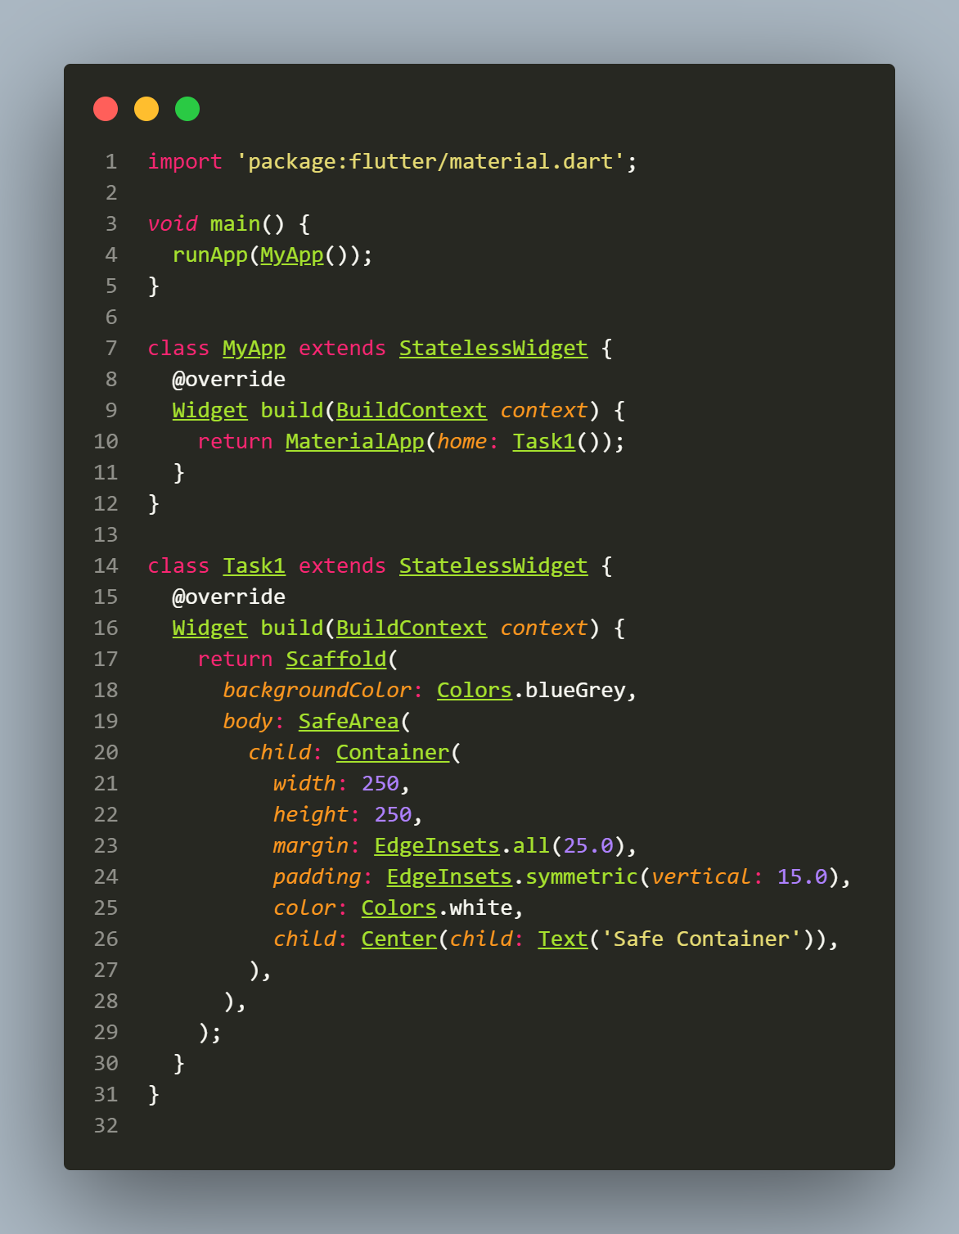

Output:
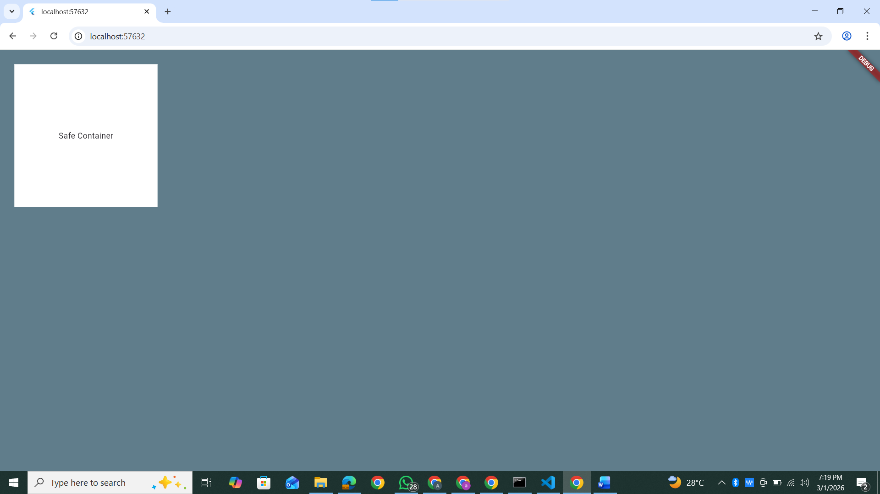

Task 2: Mastering the Vertical Axis
Objective: Practice Column alignment and manual spacing.
  - Requirements:
    - Create a Column as the primary child of your UI. o Place three icons inside: Icons.favorite, Icons.thumb_up, and Icons.share. o Use MainAxisAlignment.spaceEvenly to distribute the icons vertically. o Wrap the Column in a Container with width: double.infinity.
    - Set CrossAxisAlignment.end to push the icons to the right edge of the screen.
  - Challenge: Insert a SizedBox with a height: 60.0 between the first and second icon to create custom spacing.

Code:
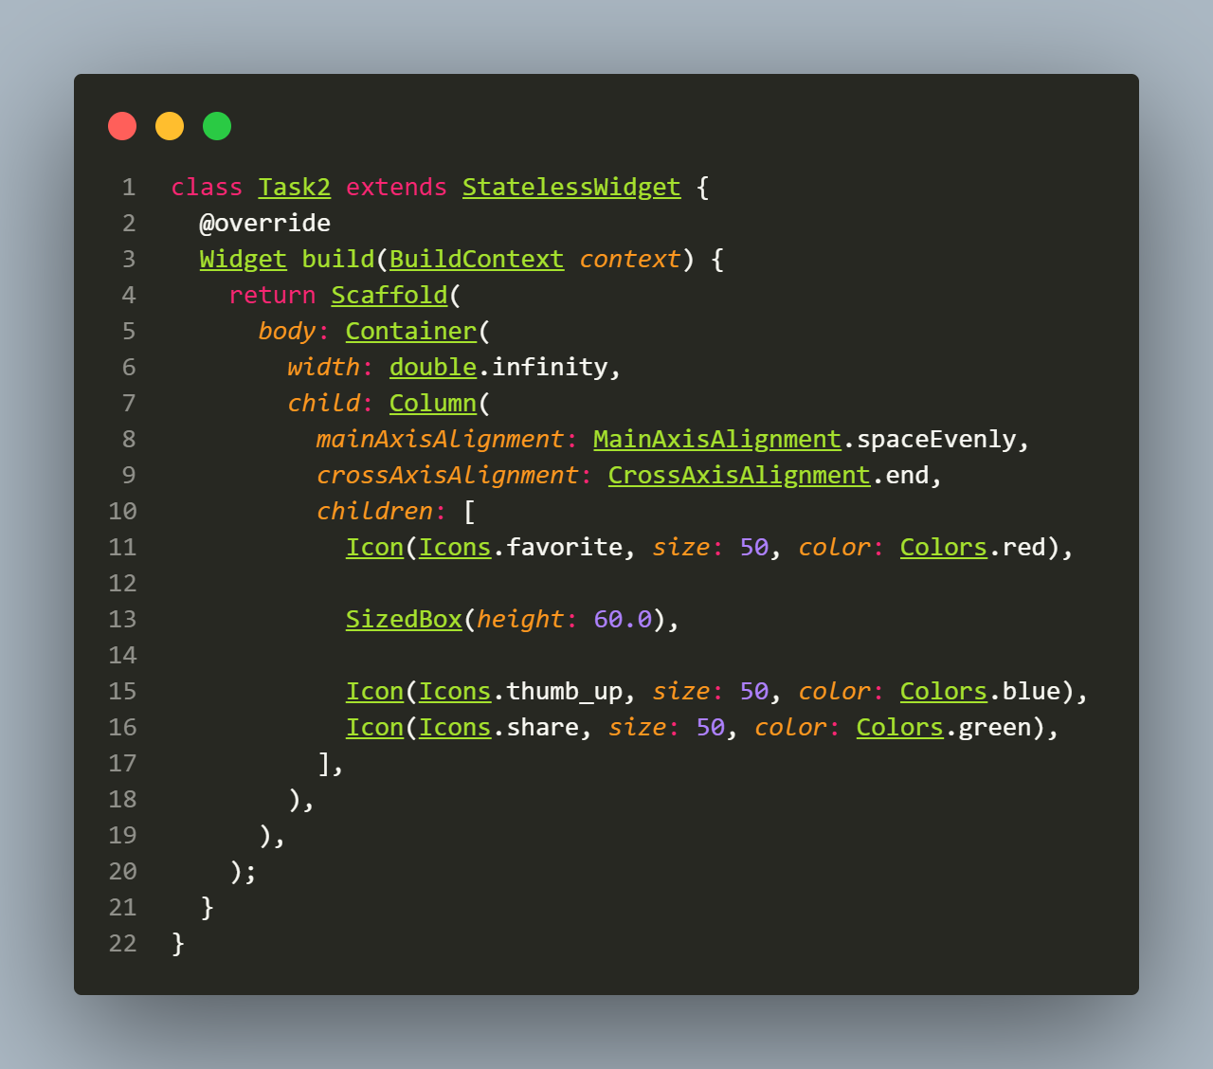

Output:
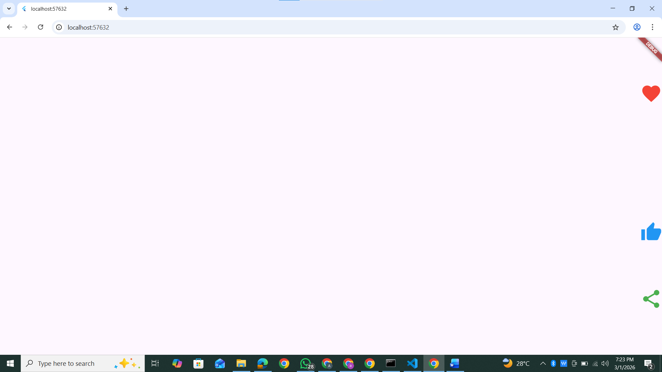

Task 3: Horizontal Flow & Axis Flipping
Objective: Contrast Row behavior with Column behavior.
  - Requirements:
    - Create a Row widget. o Add three icons: Icons.volume_up, Icons.bluetooth, and Icons.wifi. o Set the MainAxisAlignment to center.
    - Experiment with CrossAxisAlignment.stretch and observe how it affects the height of the row components.
  - Reflection: How does the "Main Axis" change when moving from a Column to a Row?.

Code:
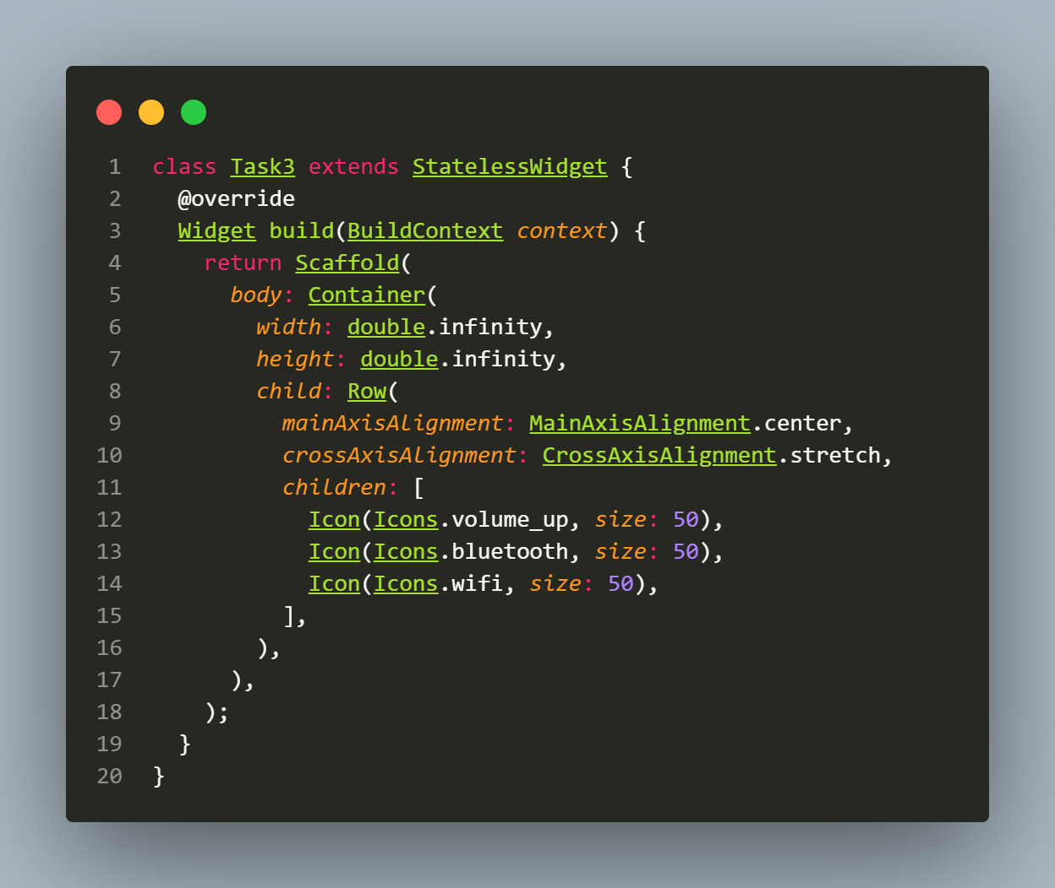

Output:
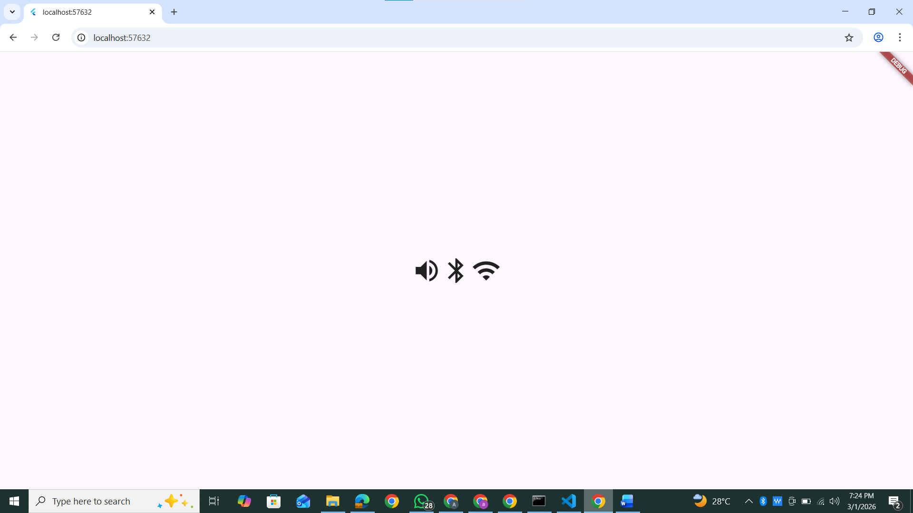

Task 4: The Final Alignment Challenge
Objective: Nest Rows and Columns to create a manual "Status Panel."
  - Requirements:
    - Parent: A Column set to MainAxisAlignment.start.
    - Child 1: A blue Container (Header) with a height of 100 and width of double.infinity.
    - Child 2: A Row containing two smaller Containers (Red and Green) representing action buttons.
    - Alignment Goal: Use MainAxisAlignment.spaceBetween on the Row to push the Red box to the far left and the Green box to the far right.
    - Spacing: Use a SizedBox to ensure exactly 20 pixels of vertical space between the blue Header and the Button Row.
Code:
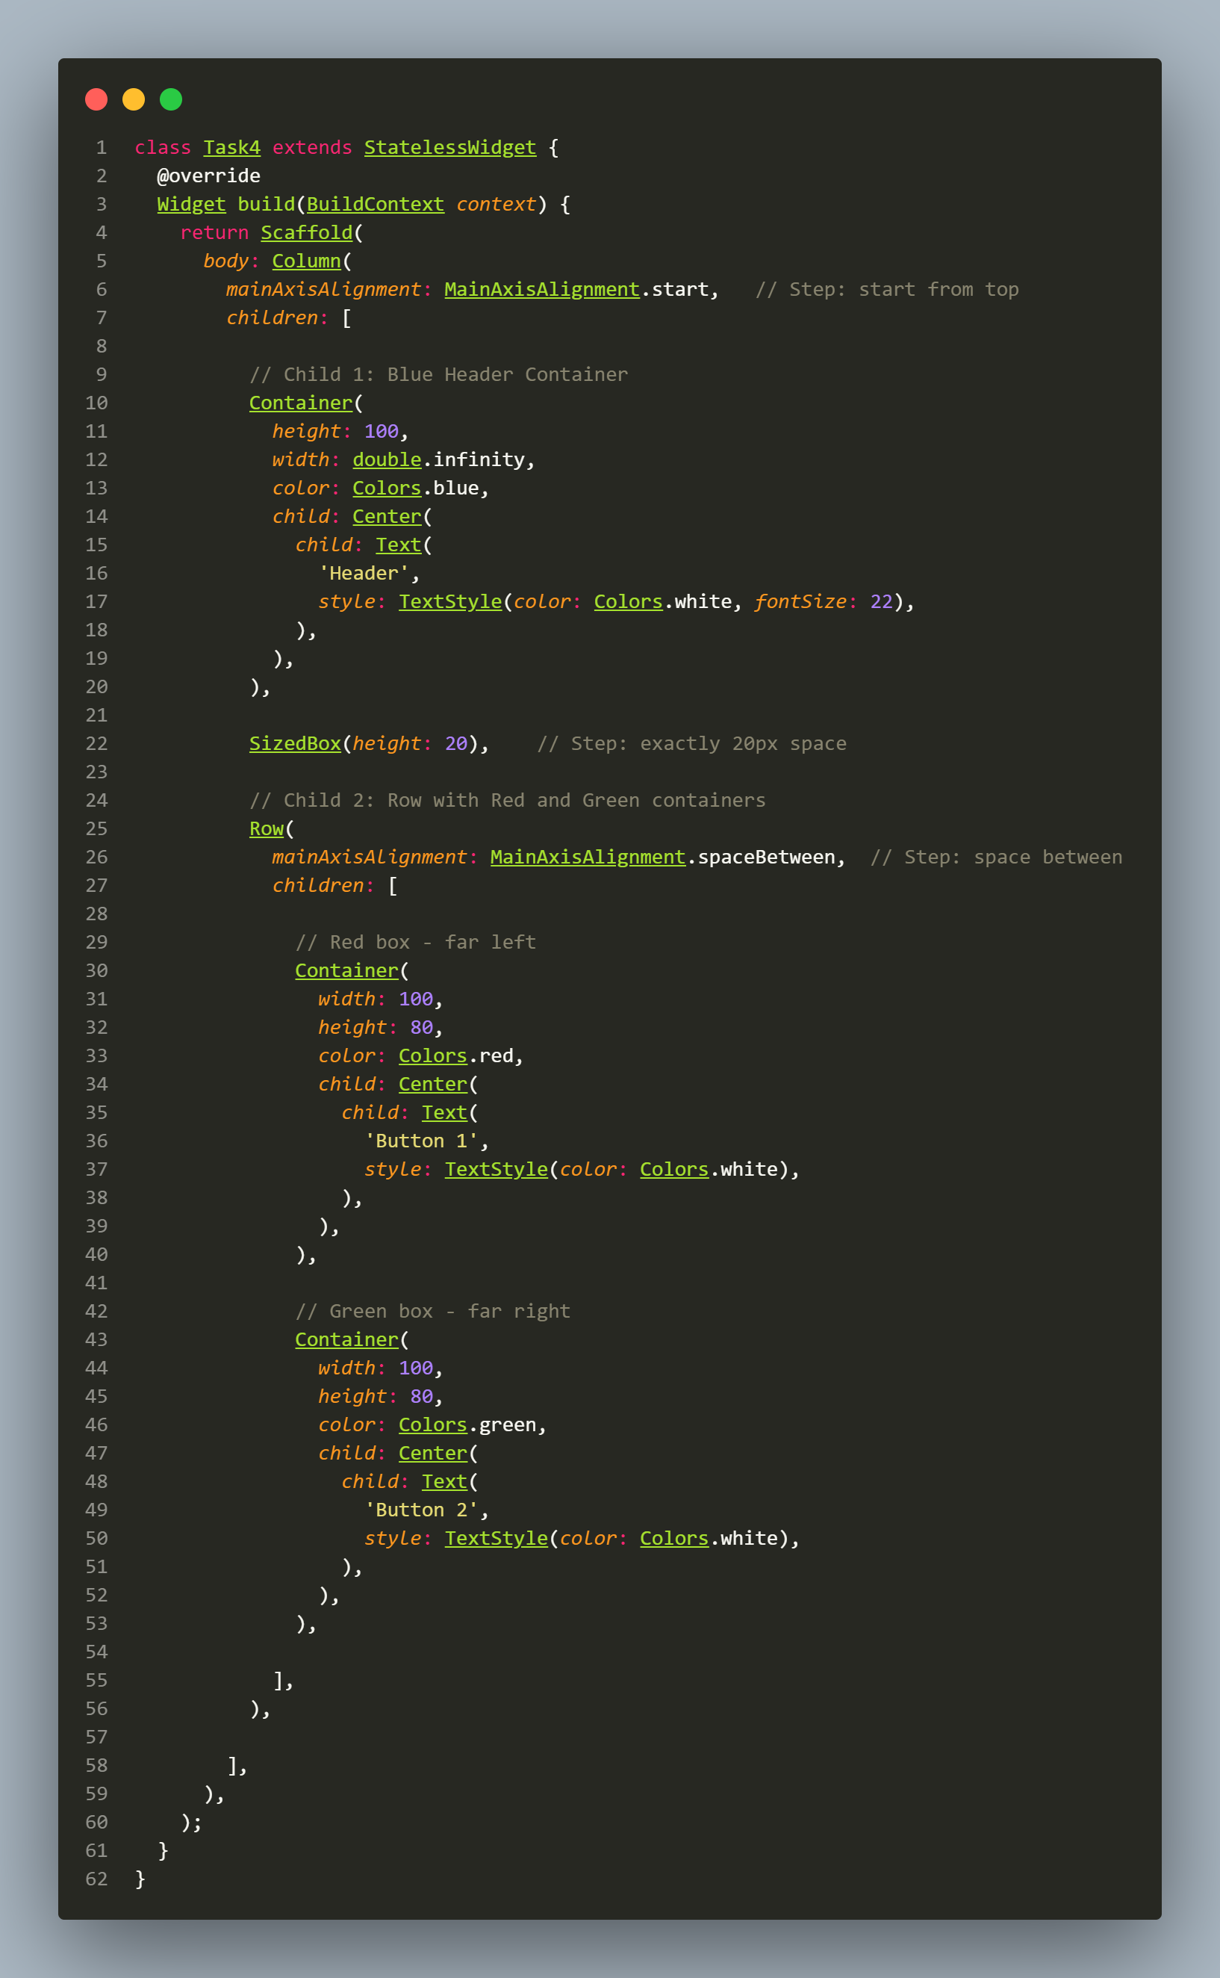
Output:
